GENERAL SPECIFICATIONS
Model 115-3 Solenoid Control Valve – Throttling Type

1.1 General
The solenoid control valve shall operate by means of discrete electrical signals. The valve shall be equipped with two two-way solenoid valves that will allow the valve to be opened, closed, or held in any intermediate position. The solenoids shall be configured so that the valve will <open, close, hold position> on loss of electric power. The solenoid control valve shall be a <size> Model 115-3, <globe pattern, angle pattern>, with <150# flanged, 300# flanged, threaded, grooved> end connections, as manufactured by OCV Control Valves, Tulsa, Oklahoma, USA.

1.2 Design
The solenoid control valve shall be a single-seated, line pressure operated, diaphragm actuated, pilot controlled globe valve. The valve shall seal by means of a corrosion-resistant seat and a resilient, rectangular seat disc. These, and other parts, shall be replaceable without removing the valve from the line. The stem of the main valve shall be guided top and bottom by integral bushings. Alignment of the body, bonnet and diaphragm assembly shall be by precision dowel pins. The diaphragm shall not be used as a seating surface, nor shall the pistons be used as an operating means. The pilot system shall be furnished complete and installed on the main valve. It shall include two needle valves, a Y-strainer, two solenoid valves and isolation ball valves. The solenoid control valve shall be operationally and hydrostatically tested prior to shipment.

1.3 Materials of Construction
The main valve body and bonnet shall be ductile iron per ASTM A536, Grade 65-45-12. End connections shall be <ANSI B16.42 Class 150# flange > <ANSI B16.42 Class 300# flange, > <ANSI B1.20.1 threaded > <grooved ends >. All ferrous surfaces shall be coated with a minimum of 4 mils of an NSF-61 approved epoxy. The main valve seat ring shall be bronze. Elastomers (diaphragms, resilient seats and O-rings) shall be Buna-N. The needle valve and isolation ball valves shall be brass, and control line tubing shall be copper. The solenoid valves shall have brass bodies, weatherproof enclosures per NEMA 4 and be suitable for operation on <voltage>.

1.4 Operating Conditions
The solenoid control valve shall be suitable for pressures of <X to X> psi at flow rates up to <X> gpm.

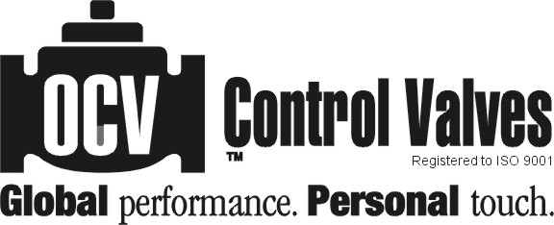
7400 E. 42nd Place, Tulsa, OK 74145-4744 USA ISSUE DATE
fax: (918) 622.8916 email: sales@controlvalves.com 10/28/2010
1.888.OCV.VALV (628.8258) www.controlvalves.com

