GENERAL SPECIFICATIONS
Model 127-3 Pressure Reducing Valve

1.1 General
The pressure reducing valve shall function to reduce a higher upstream pressure to a constant, lower downstream pressure regardless of fluctuations in supply or demand. The pressure reducing valve shall be a <size> Model 127-3, <globe pattern, angle pattern>, as manufactured by OCV Control Valves, Tulsa, Oklahoma, USA.

1.2 Design
The pressure reducing valve shall be a single-seated, line pressure operated, diaphragm actuated, pilot controlled globe valve. The valve shall seal by means of a corrosion-resistant seat and a resilient, rectangular seat disc. These, and other parts, shall be replaceable without removing the valve from the line. The stem of the main valve shall be guided top and bottom by integral bushings. Alignment of the body, bonnet and diaphragm assembly shall be by precision dowel pins. The diaphragm shall not be used as a seating surface, nor shall the pistons be used as an operating means. The pilot system shall be furnished complete and installed on the main valve. It shall include an opening speed control, Y-strainer and isolation ball valves. The pressure reducing valve shall be operationally and hydrostatically tested prior to shipment.

1.3 Materials of Construction
The main valve body and bonnet shall be ductile iron per ASTM A536, Grade 65-45-12. End connections shall be <ANSI B16.42 Class 150# flange > <ANSI B16.42 Class 300# flange>, <ANSI B1.20.1 threaded> <grooved ends>. All ferrous surfaces shall be coated with a minimum of 4 mils of an NSF-61 approved epoxy. The main valve seat ring shall be bronze. Elastomers (diaphragms, resilient seats and O-rings) shall be Buna-N. The control pilot shall be bronze. The opening speed control and isolation ball valves shall be brass, and control line tubing shall be copper.

1.4 Operating Conditions

The pressure reducing valve shall be suitable for reducing inlet pressures of <X to X> psi to a constant outlet pressure of <X> psi at flow rates ranging from <X to X> gpm.


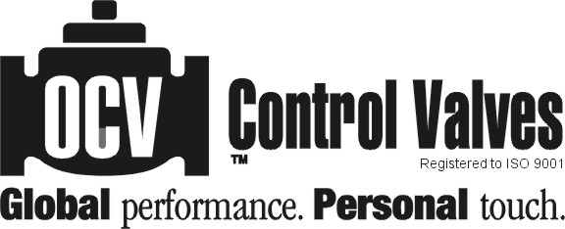
7400 E. 42nd Place, Tulsa, OK 74145-4744 USA ISSUE DATE
fax: (918) 622.8916 email: sales@controlvalves.com 10/28/2010
1.888.OCV.VALV (628.8258) www.controlvalves.com

