GENERAL SPECIFICATIONS
Model 3331-4 One-Way Altitude Valve

1.1 General
The one-way altitude valve shall function to control the level in the tank without the use of floats or probes in the tank itself. It shall be a one-way flow (single-acting) type, designed to open fully to fill the tank when the predetermined low level is reached, and close completely when the predetermined high level is reached. Sensing of the altitude pilot and drawdown pilot shall be by means of a field-installed sense line between the pilots and base of the tank. The one-way altitude valve shall be equipped with a visual indicator assembly and shall be a <size> Model 3331-4, <globe pattern, angle pattern>, as manufactured by OCV Control Valves, Tulsa, Oklahoma, USA.

1.2 Design
The one-way altitude valve shall be a single-seated, line pressure operated, diaphragm actuated, pilot controlled globe valve. The valve shall seal by means of a corrosion-resistant seat and a resilient, rectangular seat disc. These, and other parts, shall be replaceable without removing the valve from the line. The stem of the main valve shall be guided top and bottom by integral bushings. Alignment of the body, bonnet and diaphragm assembly shall be by precision dowel pins. The diaphragm shall not be used as a seating surface, nor shall the pistons be used as an operating means. The pilot system shall be furnished complete and installed on the main valve. It shall include the altitude pilot, drawdown pilot, a needle valve, Y-strainer and isolation ball valves. The one-way altitude valve shall be operationally and hydrostatically tested prior to shipment.

1.3 Materials of Construction
The main valve body and bonnet shall be ductile iron per ASTM A536, Grade 65-45-12. End connections shall be <ANSI B16.42 Class 150# flange > <ANSI B16.42 Class 300# flange>, <ANSI B1.20.1 threaded> <grooved ends>. All ferrous surfaces shall be coated with a minimum of 4 mils of an NSF-61 approved epoxy. The main valve seat ring shall be bronze. Elastomers (diaphragms, resilient seats and O-rings) shall be Buna-N. The control pilots shall be bronze. The needle valve and isolation ball valves shall be brass and control line tubing shall be copper.

1.4 Operating Conditions
The one-way altitude valve shall be suitable for a flow of <X> gpm, a maximum pressure of <X> psig, an opening level of <X> feet, and a full tank level of <X> feet.


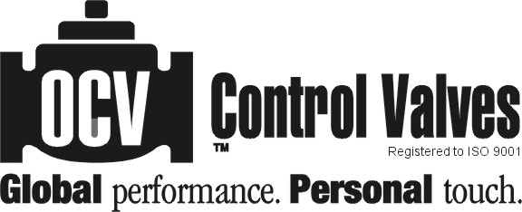
7400 E. 42nd Place, Tulsa, OK 74145-4744 USA ISSUE DATE
fax: (918) 622.8916 email: sales@controlvalves.com 10/28/2010
1.888.OCV.VALV (628.8258) www.controlvalves.com

